Experiment 4.1
Determination and plotting of Line charge density, Surface charge density and Volume charge density

Code File Name: Exp4_1_ChargeDensity.m
Code
clc;
clear;
q=input("Enter the charge value is:");
l=input("Enter the length value is:");
% Line charge density
rho_l = q/l;
disp('the line charge density is');
disp(rho_l);
% Surface charge density
r=input("Enter the radius value is:");
rho_s = q/(4*pi*r^2);
disp('the surface charge density is');
disp(rho_s);
% Volume charge density
rho_v = q/((4/3)*pi*r^3);
disp('the volume charge density is');
disp(rho_v);
% Plot
x = linspace(0.1,10,50);
y = rho_l./x;
z = rho_s./(x.^2);
v = rho_v./(x.^3);
figure;
subplot(1,3,1);
plot(x,y,'LineWidth',2);
title('Line charge density');
xlabel('Length');
subplot(1,3,2);
plot(x,z,'LineWidth',2);
title('Surface charge density');
xlabel('Radius');
subplot(1,3,3);
plot(x,v,'LineWidth',2);
title('Volume charge density');
xlabel('Radius');
Command Prompt
Enter the charge value is:2e-2
Enter the length value is:1e-3
the line charge density is
20
Enter the radius value is:2
the surface charge density is
3.9789e-04
the volume charge density is
5.9683e-04
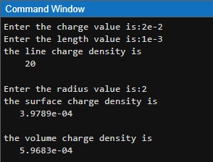

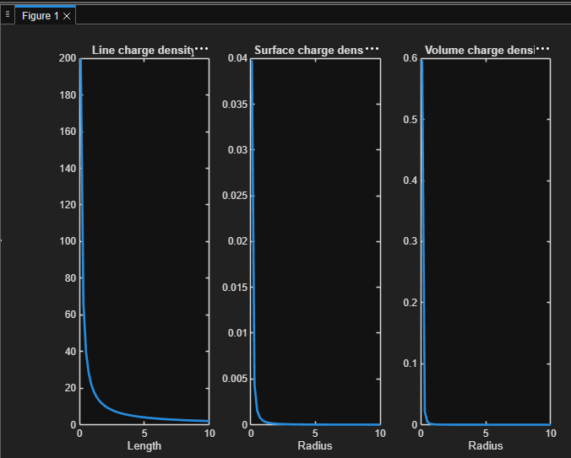
Output Graph

